**Purpose**

1. Theme

2. Resizable object

3. Draggable and droppable object

The yellow square and target square located on the login page is made to be the draggable and droppable objects. The purpose of it is making the user can play it for fun.

The searching form located on the home page is draggable. The purpose of this feature is making the user can put the form into their comfortable location.

4. AJAX tab

The login and registration tab located on the login page is made to be AJAX tabs. The purpose of it is making the user can load different forms into the page without refreshing the web page.

5. jQuery Dialog

6. jQuery sortable list

The login and registration tab located on the login page is made to be a sortable list. The purpose of it is making the user can sort the tab into their favorite order.

**Behave**

1. Theme

2. Resizable object

3. Draggable and droppable object

On the login page, if you drag the green square into the target square, the behave of the target square will change.

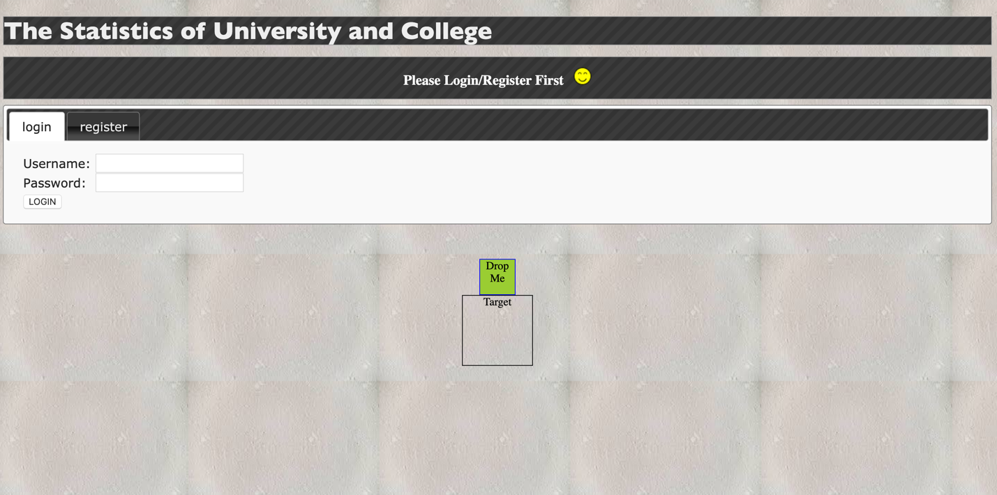

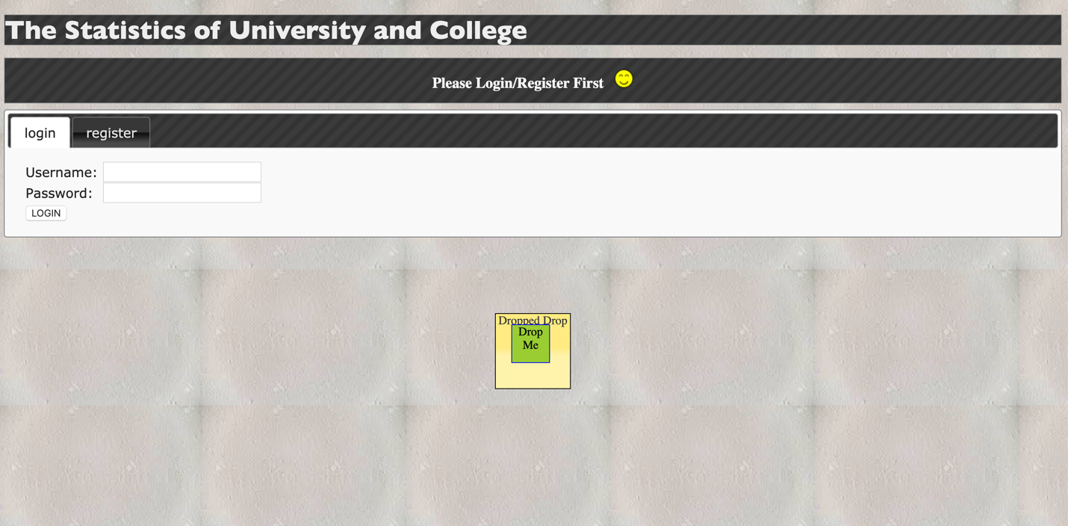

On the home page, the searching form can be dragged to any location of the page.

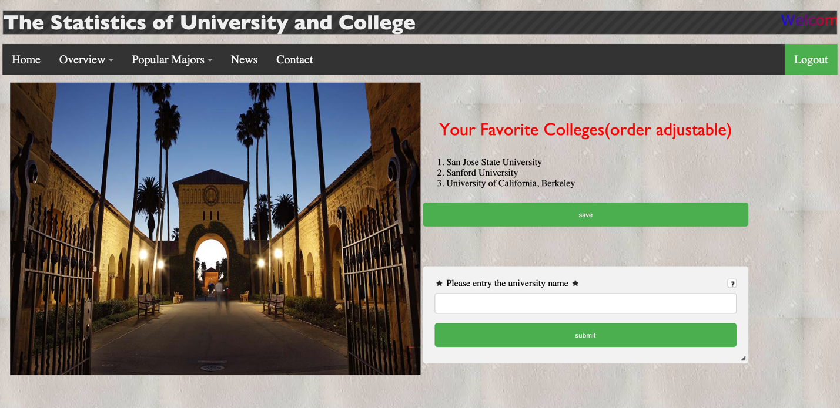

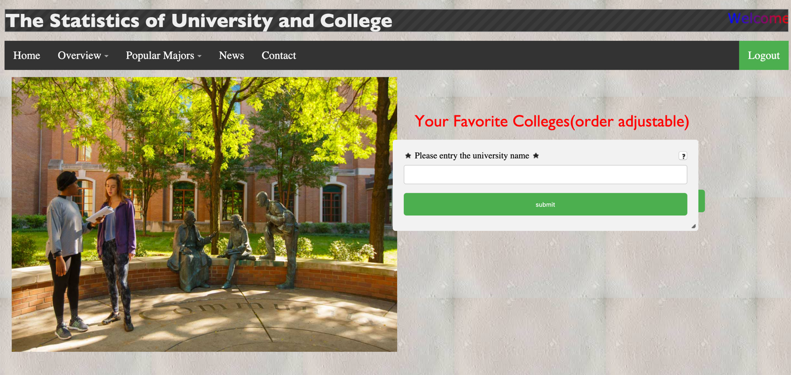

4. AJAX tab

The login and registration tab located on the home page are AJAX tabs. If the user clicks on the registration tab, the registration form will be loaded into the page. If the user clicks on the login tab, the login form will be loaded into the page.

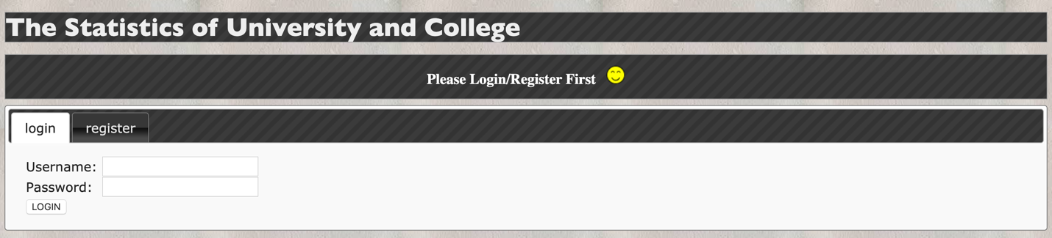

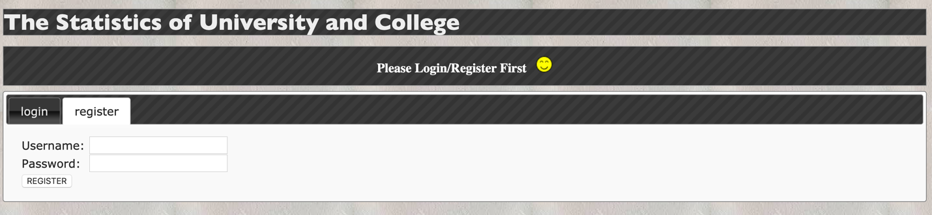

5. jQuery Dialog

6. jQuery sortable list

The login and registration tab located on the home page can be sorted by the user into their favorite order.

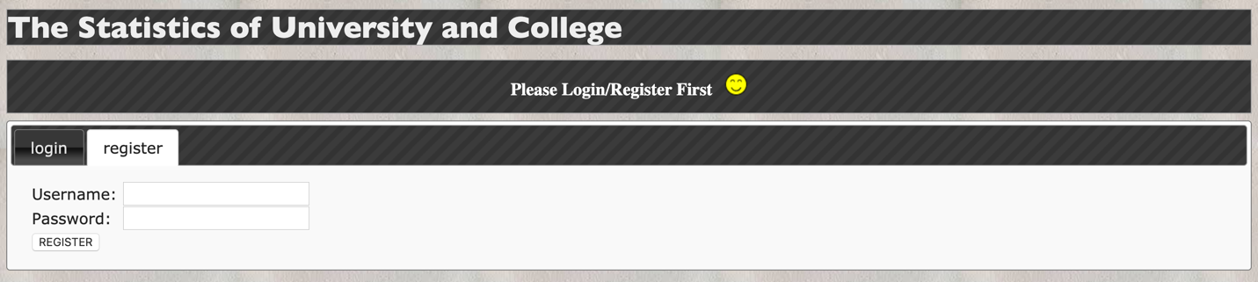

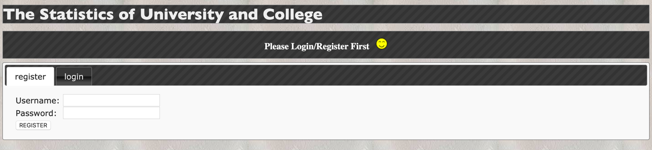

**Implementation**

1. Theme

2. Resizable object

3. Draggable and droppable object

* Draggable and droppable object on the login page

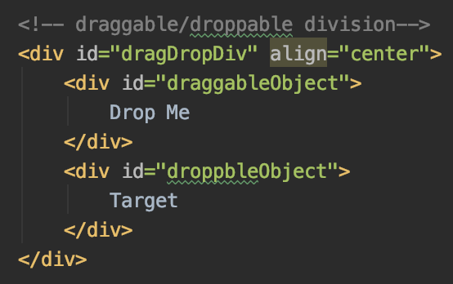

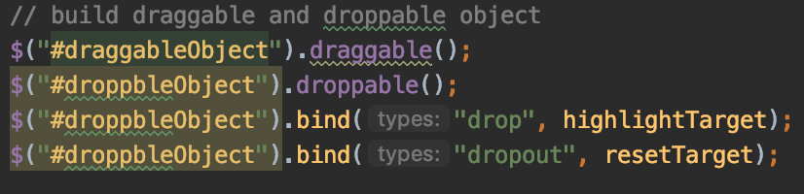

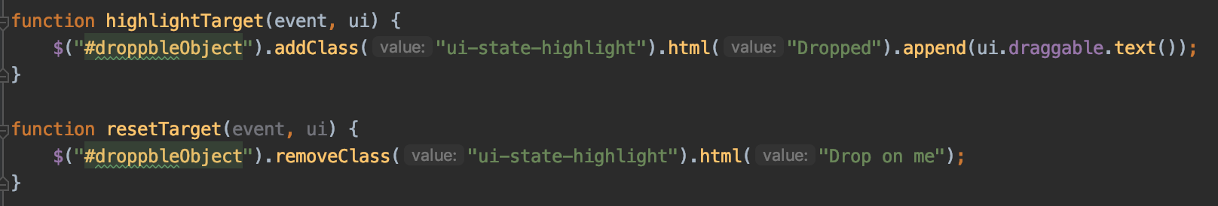

* Draggable searching form on the home page

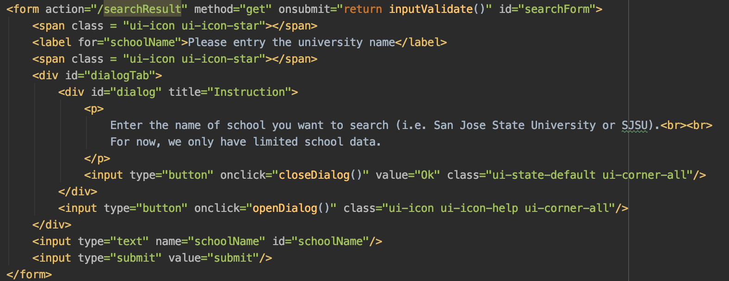



4. AJAX tab

* Login and registration AJAX tab on the login page

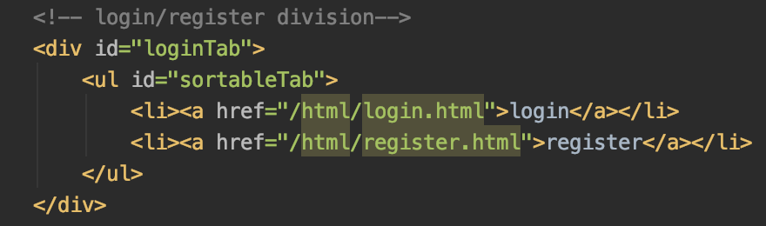

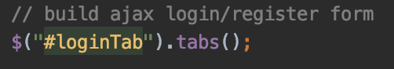

5. jQuery Dialog

6. jQuery sortable list

* Login and registration tab on the home page

